**Assignment 2.2**

**3. Task 3**

Created file “max-temp.txt”

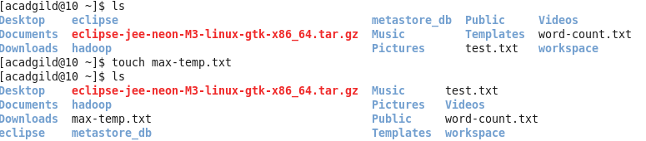

Added data to file and moved it to Hadoop FS.

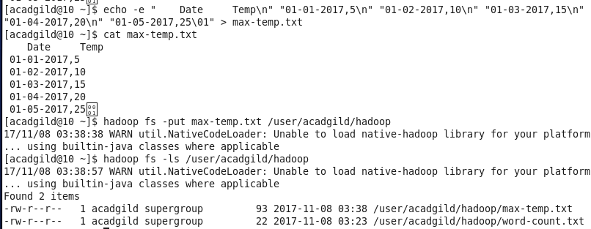

**4. Task 4**

As per last screenshot of Task 3, only supergroup user have access to this file. So creating new user in hadoop and will provide access to him.

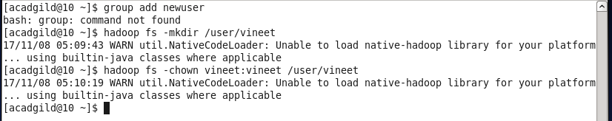

Command not working

